**ຂັ້ນຕອນການສ້າງແອປ Bluetooth ໃນການປິດ-ເປິດໄຟມີດັ່ງນີ້:**

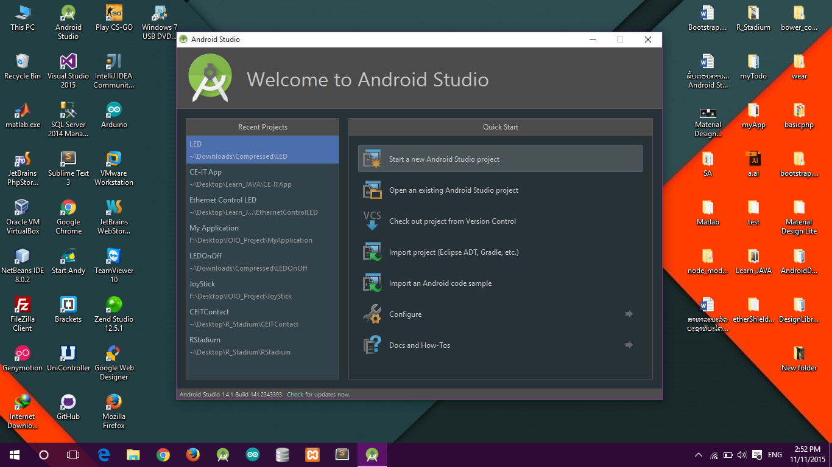

1

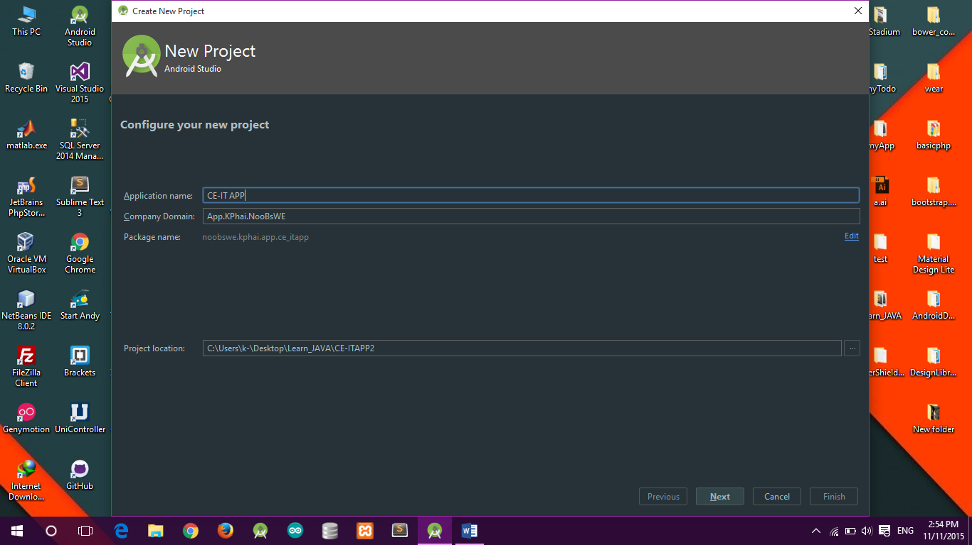

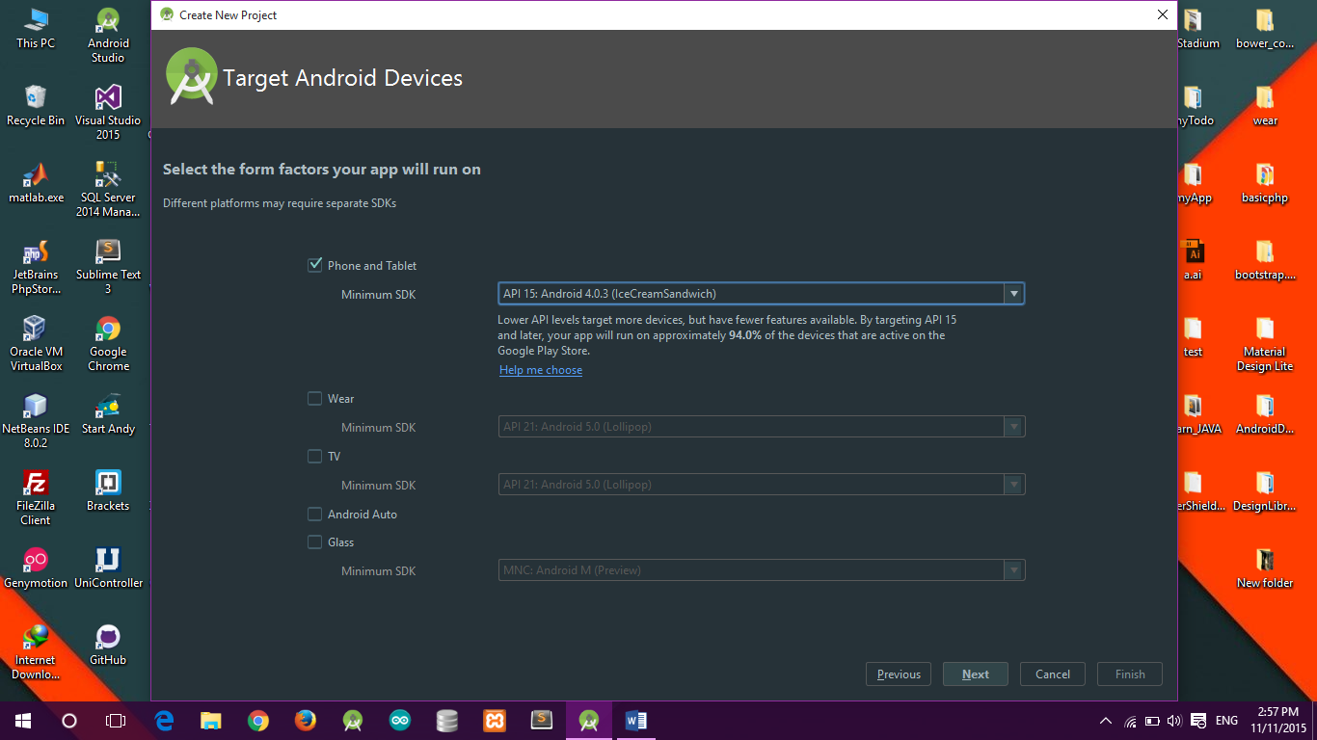

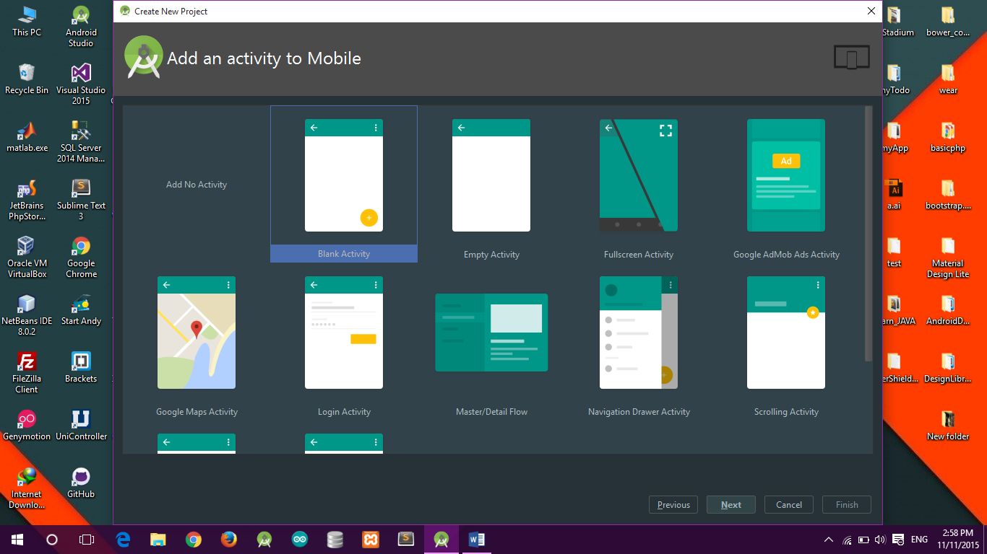

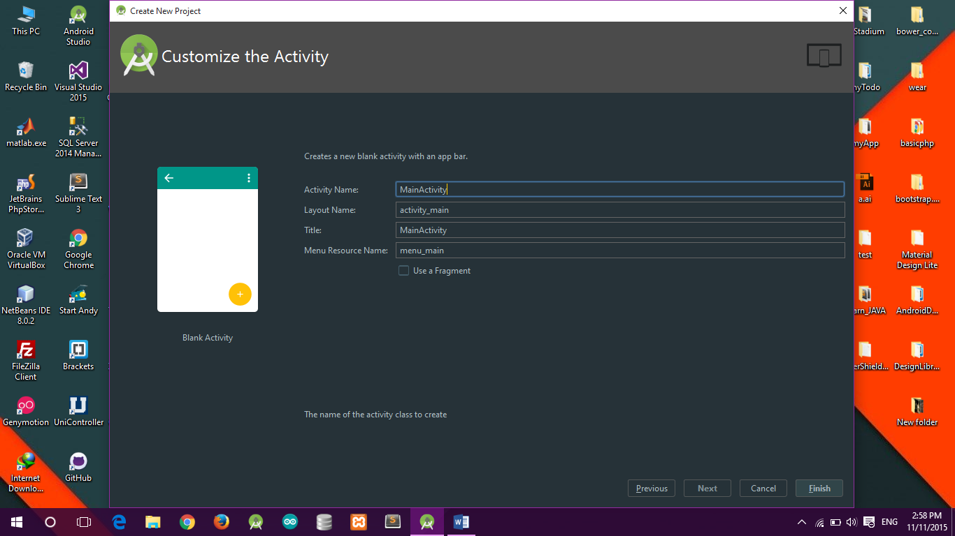

***ຫລັງຈາກເລີ່ມໂປເຈັກແລ້ວຈະເຫັນຫນ້າດັ່ງລຸ່ມນີ້***

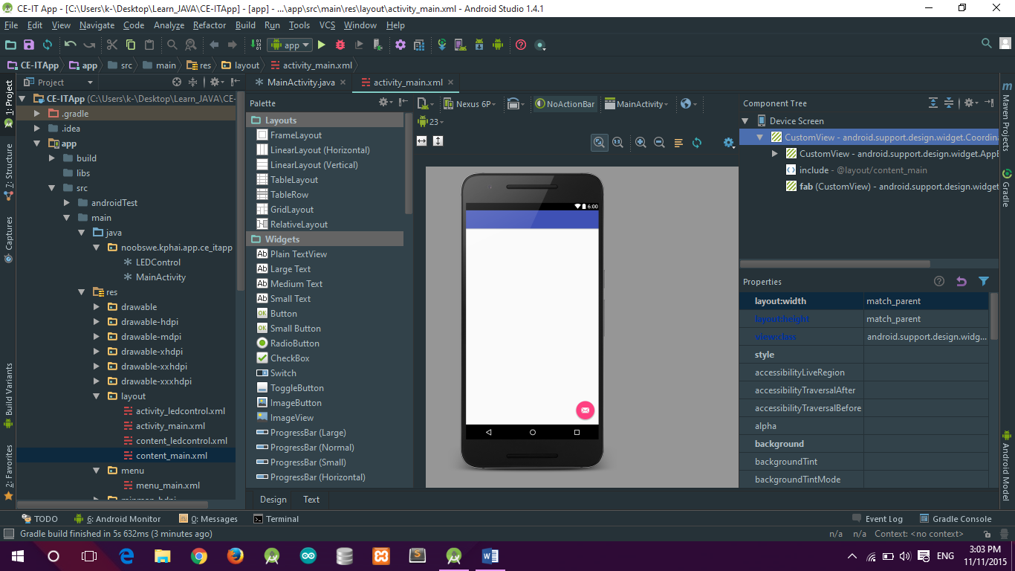

***res 🡪 Layout 🡪 Content_main.xml***

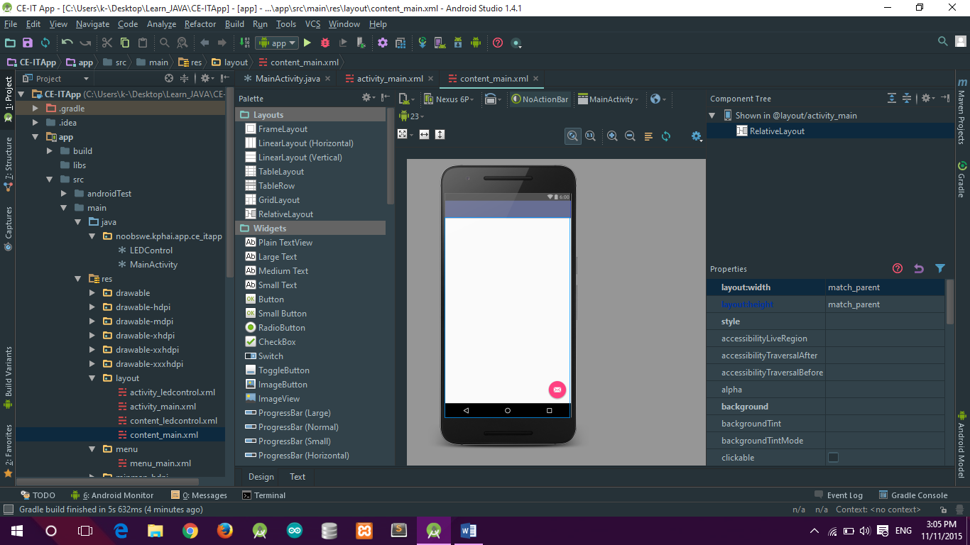

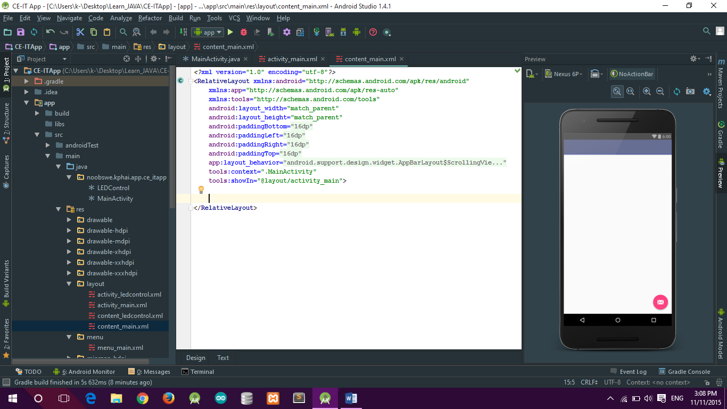

***ເພີ່ມໂຄດໃສ່ຟ່າຍ Content_main.xml ດັ່ງນີ້:***

*<?***xml version="1.0" encoding="utf-8"***?>*<**RelativeLayout xmlns:android="http://schemas.android.com/apk/res/android"  
 xmlns:app="http://schemas.android.com/apk/res-auto"  
 xmlns:tools="http://schemas.android.com/tools"  
 android:layout_width="match_parent"  
 android:layout_height="match_parent"  
 android:paddingBottom="@dimen/activity_vertical_margin"  
 android:paddingLeft="@dimen/activity_horizontal_margin"  
 android:paddingRight="@dimen/activity_horizontal_margin"  
 android:paddingTop="@dimen/activity_vertical_margin"  
 app:layout_behavior="@string/appbar_scrolling_view_behavior"  
 tools:context=".MainActivity"  
 tools:showIn="@layout/activity_main"**>  
  
 <**TextView  
 android:id="@+id/textView"  
 android:layout_width="wrap_content"  
 android:layout_height="wrap_content"  
 android:layout_alignParentLeft="true"  
 android:layout_alignParentStart="true"  
 android:layout_alignParentTop="true"  
 android:text="ເລືອກອຸປະກອນເພື້ອຈັບຄູ່"** />  
  
 <**Button  
 android:id="@+id/paired"  
 android:layout_width="wrap_content"  
 android:layout_height="wrap_content"  
 android:layout_alignParentBottom="true"  
 android:layout_alignParentEnd="true"  
 android:layout_alignParentLeft="true"  
 android:layout_alignParentRight="true"  
 android:layout_alignParentStart="true"  
 android:text="ຄົ້ນຫາອຸປະກອນຈັບຄູ່"** />  
  
 <**ListView  
 android:id="@+id/devicelist"  
 android:layout_width="wrap_content"  
 android:layout_height="wrap_content"  
 android:layout_above="@+id/paired"  
 android:layout_below="@+id/textView"  
 android:layout_centerHorizontal="true"** />  
</**RelativeLayout**>

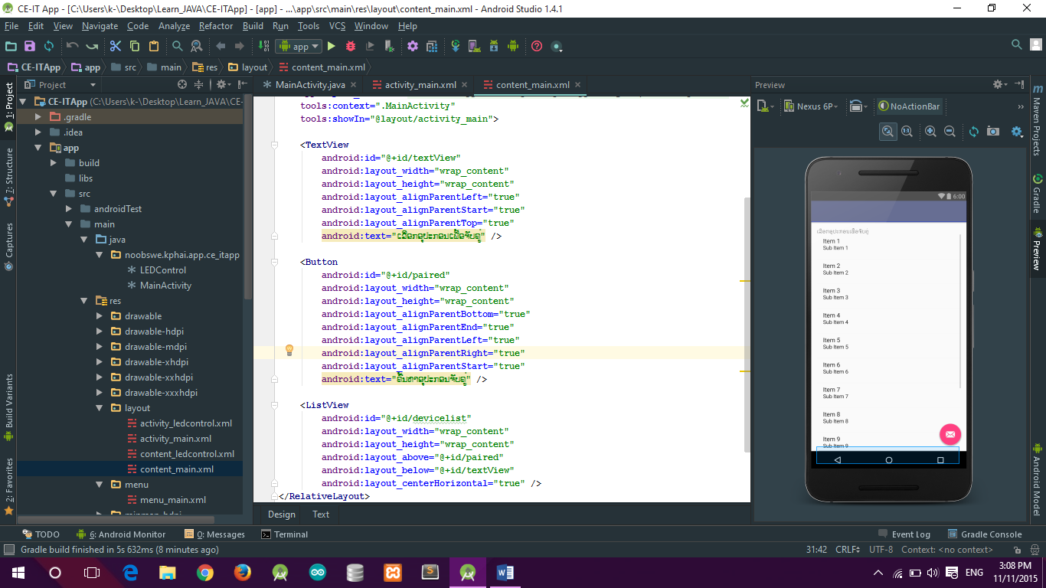

***main 🡪 java 🡪 MainActivity.java***

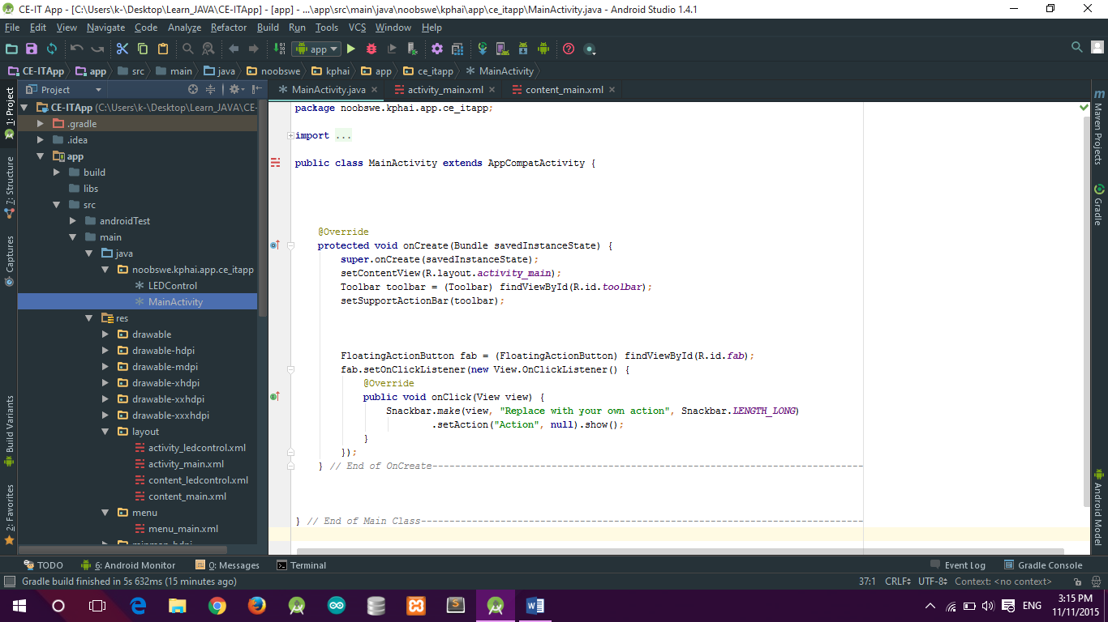

***ເພີ່ມໂຄດໃສ່ຟ່າຍ MainActivity.java* *ດັ່ງນີ້:***

**package** noobswe.kphai.app.ce_itapp;  
  
**import** android.bluetooth.BluetoothAdapter;  
**import** android.bluetooth.BluetoothDevice;  
**import** android.content.Context;  
**import** android.content.Intent;  
**import** android.os.Bundle;  
**import** android.os.Vibrator;  
**import** android.support.design.widget.FloatingActionButton;  
**import** android.support.design.widget.Snackbar;  
**import** android.support.v7.app.AppCompatActivity;  
**import** android.support.v7.widget.Toolbar;  
**import** android.view.View;  
**import** android.view.Menu;  
**import** android.view.MenuItem;  
**import** android.widget.AdapterView;  
**import** android.widget.ArrayAdapter;  
**import** android.widget.Button;  
**import** android.widget.ListView;  
**import** android.widget.TextView;  
**import** android.widget.Toast;  
  
**import** java.util.ArrayList;  
**import** java.util.Set;  
  
**public class** MainActivity **extends** AppCompatActivity {  
  
 Button **btnPaired**;  
 Vibrator **vibrator**;  
 ListView **devicelist**;  
  
 *//Bluetooth* **private** BluetoothAdapter **myBluetooth** = **null**;  
 **private** Set<BluetoothDevice> **pairedDevices**;  
 **public static** String *EXTRA_ADDRESS* = **"device_address"**;  
  
  
 @Override  
 **protected void** onCreate(Bundle savedInstanceState) {  
 **super**.onCreate(savedInstanceState);  
 setContentView(R.layout.***activity_main***);  
 Toolbar toolbar = (Toolbar) findViewById(R.id.***toolbar***);  
 setSupportActionBar(toolbar);  
  
 **btnPaired** = (Button) findViewById(R.id.***paired***);  
 **devicelist** = (ListView) findViewById(R.id.***devicelist***);  
  
 **myBluetooth** = BluetoothAdapter.*getDefaultAdapter*();  
  
 **if** (**myBluetooth** == **null**) {  
 Toast.*makeText*(getApplicationContext(), **"Bluetooth Device Not Available"**, Toast.***LENGTH_LONG***).show();  
 finish();  
 }**else if** (!**myBluetooth**.isEnabled()) {  
 *//Toast.makeText(getApplicationContext(), "",Toast.LENGTH_LONG).show();* Intent turnOnBT = **new** Intent(BluetoothAdapter.***ACTION_REQUEST_ENABLE***);  
 startActivityForResult(turnOnBT, 1);  
  
 }  
  
 **vibrator** = (Vibrator) getSystemService(Context.***VIBRATOR_SERVICE***);  
  
 **btnPaired**.setOnClickListener(**new** View.OnClickListener() {  
 @Override  
 **public void** onClick(View v) {  
 **vibrator**.vibrate(50);  
 pairedDevicesList();  
 }  
 });  
  
*// FloatingActionButton fab = (FloatingActionButton) findViewById(R.id.fab);  
// fab.setOnClickListener(new View.OnClickListener() {  
// @Override  
// public void onClick(View view) {  
// Snackbar.make(view, "Replace with your own action", Snackbar.LENGTH_LONG)  
// .setAction("Action", null).show();  
// }  
// });* } *// End of OnCreate-----------------------------------------------------* **private void** pairedDevicesList() {  
 **pairedDevices** = **myBluetooth**.getBondedDevices();  
 ArrayList list = **new** ArrayList();  
  
 **if** (**pairedDevices**.size() > 0) {  
 **for** (BluetoothDevice bt : **pairedDevices**) {  
 list.add(bt.getName() + **"\n"** + bt.getAddress());  
 }  
 }**else** {  
 Toast.*makeText*(getApplicationContext(), **"No Paired Bluetooth Devices Found."**, Toast.***LENGTH_LONG***).show();  
 }  
  
 **final** ArrayAdapter adapter = **new** ArrayAdapter(**this**, android.R.layout.***simple_list_item_1***, list);  
 **devicelist**.setAdapter(adapter);  
 **devicelist**.setOnItemClickListener(**myListClickListener**);  
 }  
  
 **private** AdapterView.OnItemClickListener **myListClickListener** = **new** AdapterView.OnItemClickListener() {  
 @Override  
 **public void** onItemClick(AdapterView<?> parent, View view, **int** position, **long** id) {  
 String info = ((TextView) view).getText().toString();  
 String address = info.substring(info.length() - 17);  
  
 Intent i = **new** Intent(MainActivity.**this**, LEDControl.**class**);  
  
  
 i.putExtra(*EXTRA_ADDRESS*, address); *//this will be received at ledControl (class) Activity* startActivity(i);  
 }  
 };  
  
  
} *// End of Main Class------------------------------------------*

***ໄປທີ່ src 🡪 AndroidManifest.xml***

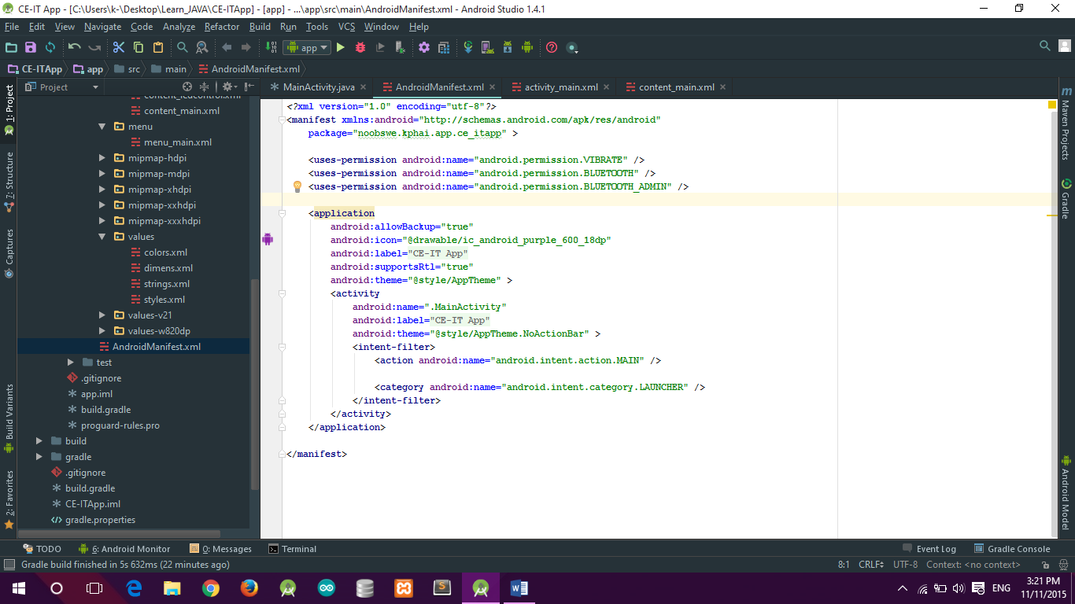

***ເພີ່ມໂຄດໃສ່ຟ່າຍ AndroidManifest.xml ດັ່ງນີ້:***

*<?***xml version="1.0" encoding="utf-8"***?>*<**manifest xmlns:android="http://schemas.android.com/apk/res/android"  
 package="noobswe.kphai.app.ce_itapp"** >  
  
 <**uses-permission android:name="android.permission.VIBRATE"** />  
 <**uses-permission android:name="android.permission.BLUETOOTH"** />  
 <**uses-permission android:name="android.permission.BLUETOOTH_ADMIN"** />  
  
 <**application  
 android:allowBackup="true"  
 android:icon="@drawable/ic_android_purple_600_18dp"  
 android:label="@string/app_name"  
 android:supportsRtl="true"  
 android:theme="@style/AppTheme"** >  
 <**activity  
 android:name=".MainActivity"  
 android:label="@string/app_name"  
 android:theme="@style/AppTheme.NoActionBar"** >  
 <**intent-filter**>  
 <**action android:name="android.intent.action.MAIN"** />  
  
 <**category android:name="android.intent.category.LAUNCHER"** />  
 </**intent-filter**>  
 </**activity**>  
 </**application**>  
  
</**manifest**>

***ສ້າງ Activity ໃຫມ່ຂື້ນມາ ໂດຍຄິດຂວາໃສ່ “ main 🡪 java 🡪 package ທີ່ໃສ່ແຕ່ເລີ່ມ project ໃນນີ້ຈະໃສວ່າ: noobswe.kphai.app.ceit_app ”***

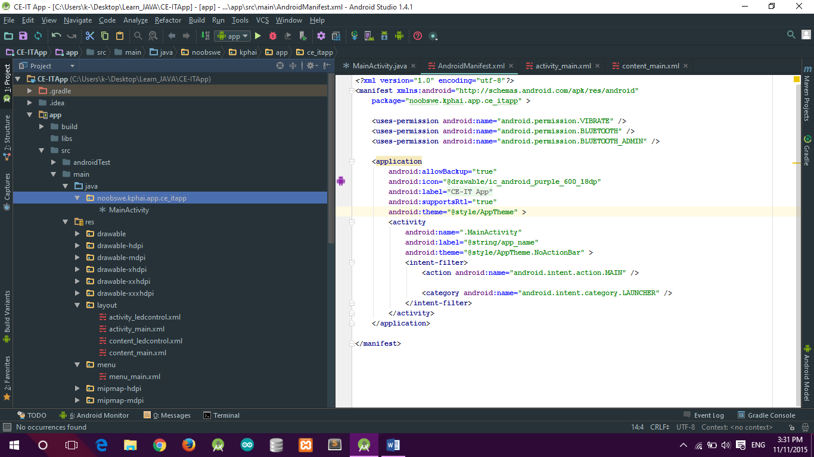

***ໄປທີ່ New 🡪 Activity 🡪 Blank Activity***

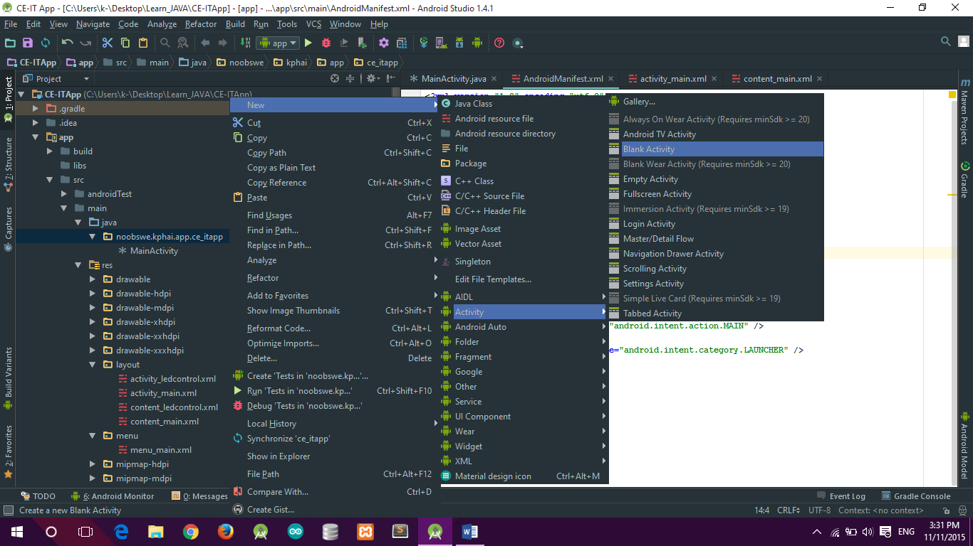

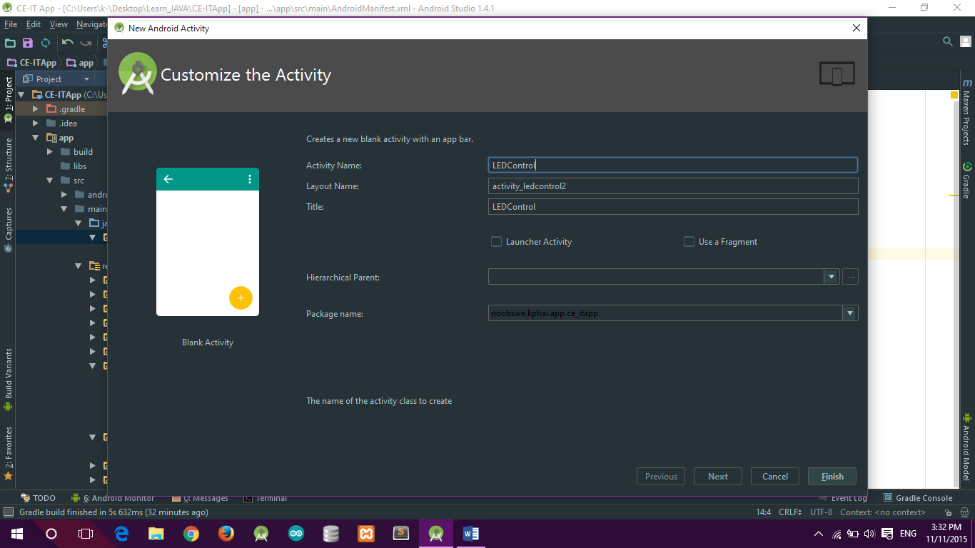

***res 🡪 Layout 🡪 Content_ledcontrol.xml***

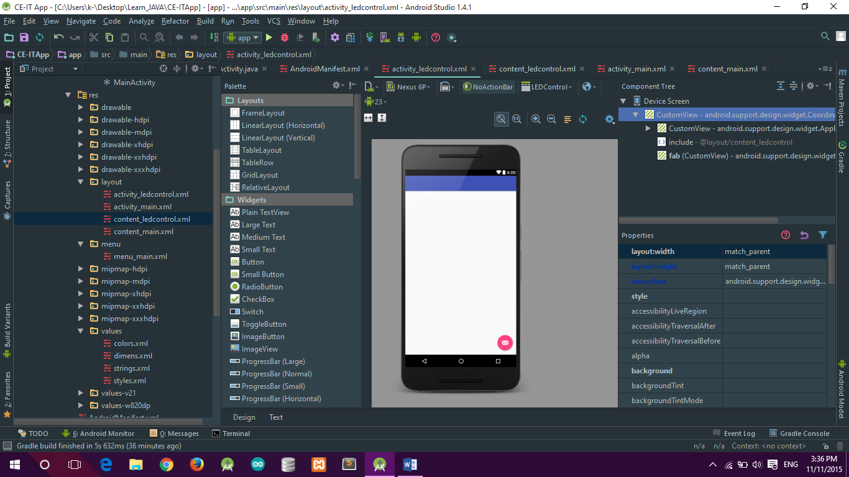

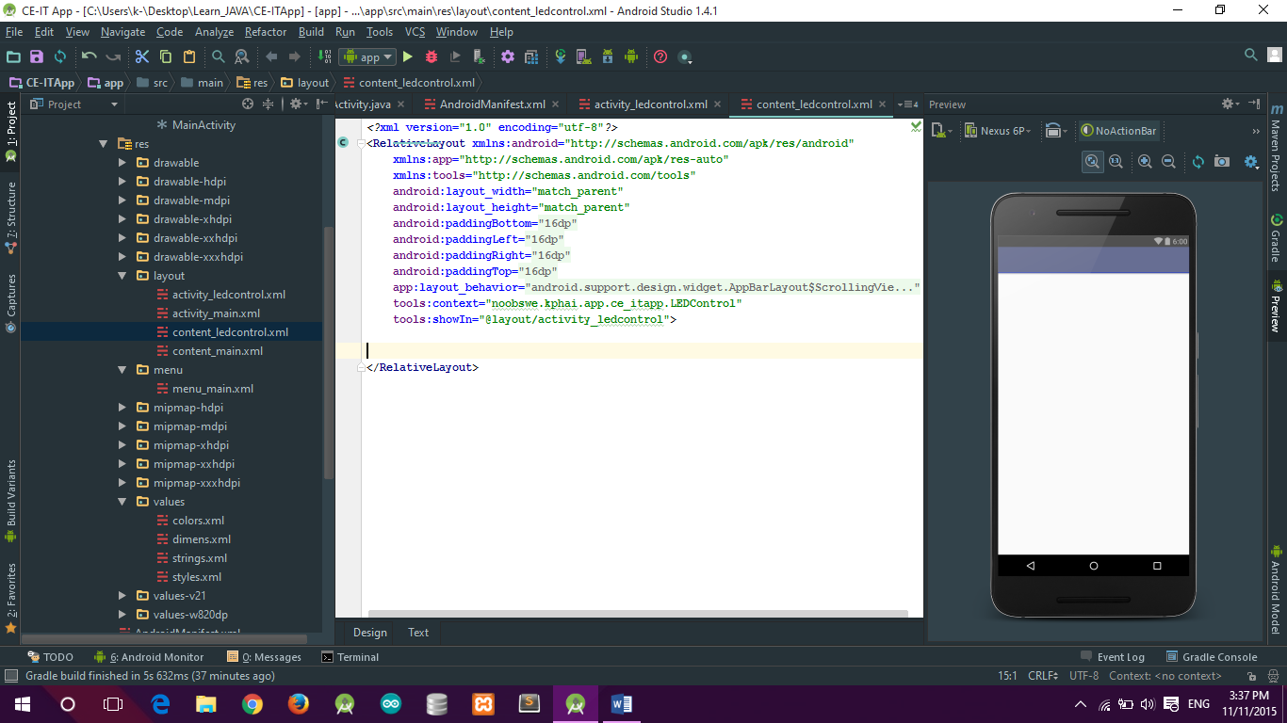

***ເພີ່ມໂຄດໃສ່ຟ່າຍ Content_ledcontrol.xml ດັ່ງນີ້:***

<**RelativeLayout xmlns:android="http://schemas.android.com/apk/res/android"  
 xmlns:app="http://schemas.android.com/apk/res-auto"  
 xmlns:tools="http://schemas.android.com/tools"  
 android:layout_width="match_parent"  
 android:layout_height="match_parent"  
 android:paddingBottom="@dimen/activity_vertical_margin"  
 android:paddingLeft="@dimen/activity_horizontal_margin"  
 android:paddingRight="@dimen/activity_horizontal_margin"  
 android:paddingTop="@dimen/activity_vertical_margin"  
 app:layout_behavior="@string/appbar_scrolling_view_behavior"  
 tools:context="noobswe.kphai.app.ce_itapp.LEDControl"  
 tools:showIn="@layout/activity_ledcontrol"**>  
  
 <**TextView  
 android:layout_width="wrap_content"  
 android:layout_height="wrap_content"  
 android:text="ຄວບຄຸມດອກໄຟ LED 1"  
 android:id="@+id/textView"  
 android:layout_centerHorizontal="true"  
 android:textSize="20dp"** />  
  
 <**Button  
 android:layout_width="match_parent"  
 android:layout_height="wrap_content"  
 android:text="ເປິດ"  
 android:id="@+id/btnon"  
 android:layout_marginTop="30dp"  
 android:layout_below="@+id/textView"  
 android:layout_alignParentLeft="true"  
 android:layout_alignParentStart="true"  
 android:background="@drawable/clickon"** />  
  
 <**Button  
 android:layout_width="wrap_content"  
 android:layout_height="wrap_content"  
 android:text="ປິດ"  
 android:id="@+id/btnoff"  
 android:layout_marginTop="15dp"  
 android:layout_below="@+id/btnon"  
 android:layout_alignParentLeft="true"  
 android:layout_alignParentStart="true"  
 android:layout_alignRight="@+id/btnon"  
 android:layout_alignEnd="@+id/btnon"  
 android:background="@drawable/clickoff"** />  
  
  
  
  
  
 <**Button  
 android:layout_width="match_parent"  
 android:layout_height="wrap_content"  
 android:text="ຢຸດການຈັບຄູ່"  
 android:id="@+id/btndis"  
 android:layout_alignParentBottom="true"  
 android:layout_alignParentLeft="true"  
 android:layout_alignParentStart="true"** />  
</**RelativeLayout**>

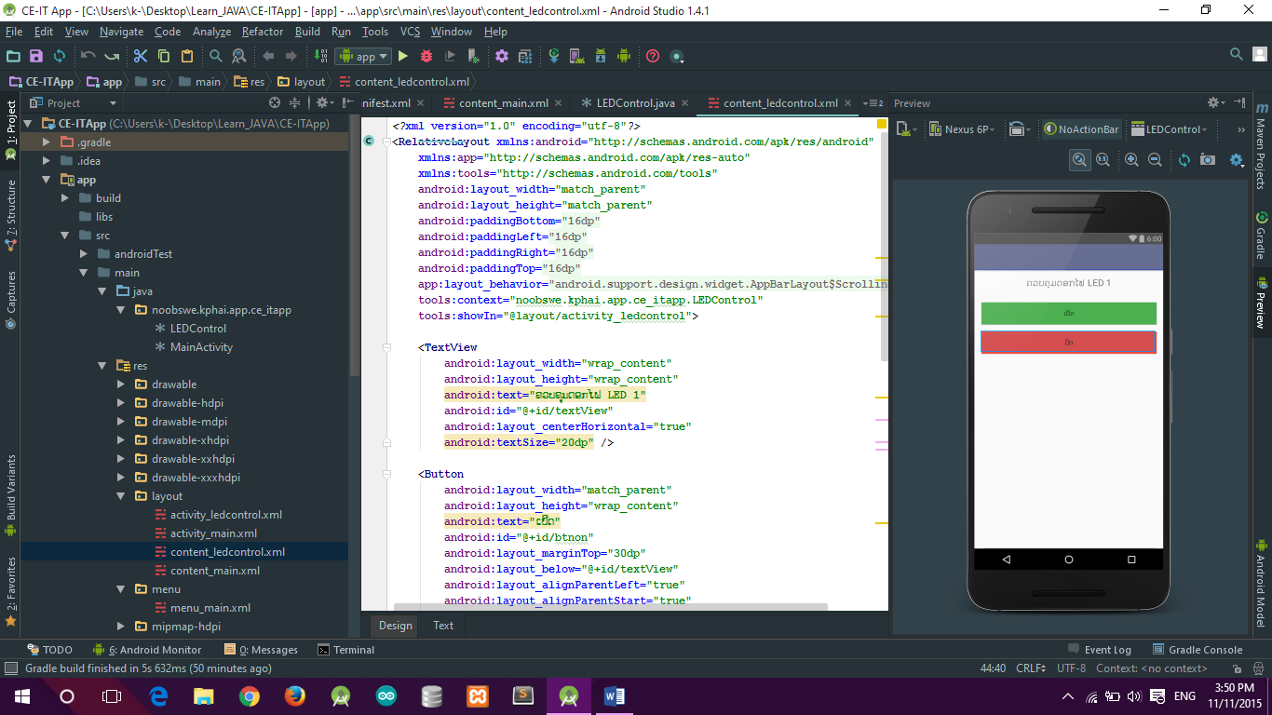

***main 🡪 java 🡪 LEDControl.java***

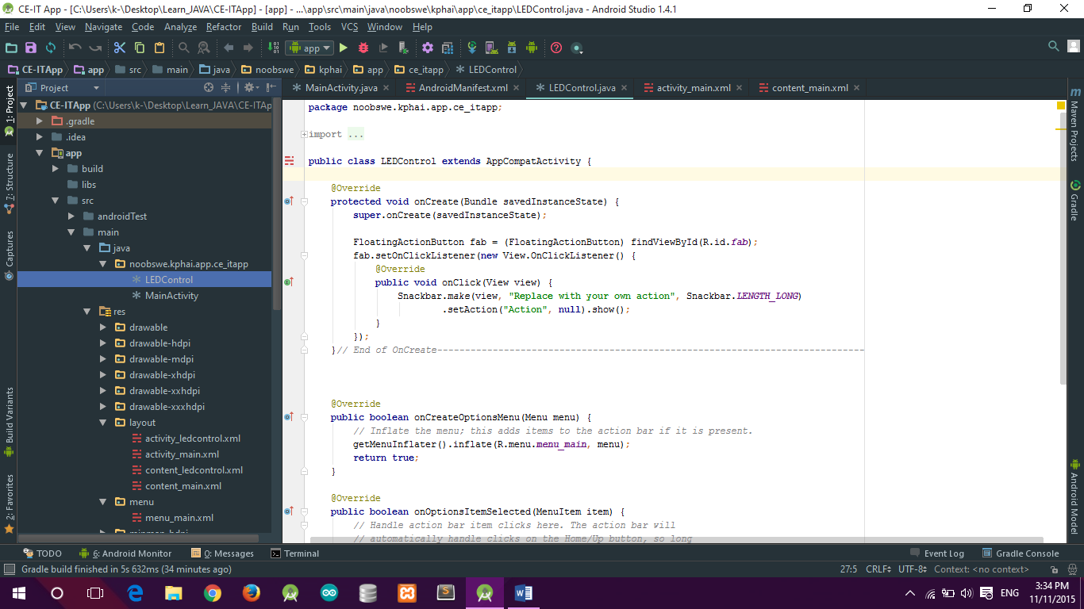

***ເພີ່ມໂຄດໃສ່ຟ່າຍ LEDControl.java ດັ່ງນີ້:***

**package** noobswe.kphai.app.ce_itapp;  
  
**import** android.app.AlertDialog;  
**import** android.app.ProgressDialog;  
**import** android.bluetooth.BluetoothAdapter;  
**import** android.bluetooth.BluetoothDevice;  
**import** android.bluetooth.BluetoothSocket;  
**import** android.content.Context;  
**import** android.content.Intent;  
**import** android.os.AsyncTask;  
**import** android.os.Bundle;  
**import** android.os.Vibrator;  
**import** android.support.design.widget.FloatingActionButton;  
**import** android.support.design.widget.Snackbar;  
**import** android.support.v7.app.AppCompatActivity;  
**import** android.support.v7.widget.Toolbar;  
**import** android.view.Menu;  
**import** android.view.MenuItem;  
**import** android.view.View;  
**import** android.widget.Button;  
**import** android.widget.Toast;  
  
**import** java.io.IOException;  
**import** java.util.UUID;  
  
**public class** LEDControl **extends** AppCompatActivity {  
  
 Button **btnOn**, **btnOff**, **btnDis**;  
 Vibrator **vibrator**;  
 String **address** = **null**;  
 **private** ProgressDialog **dialog**;  
 BluetoothAdapter **myBluetoothAdapter** = **null**;  
 BluetoothSocket **myBluetoothSocket** = **null**;  
 **private boolean isBTConnected** = **false**;  
 *//SPP UUID. Look for it* **static final** UUID ***myUUID*** = UUID.*fromString*(**"00001101-0000-1000-8000-00805F9B34FB"**);  
  
 @Override  
 **protected void** onCreate(Bundle savedInstanceState) {  
 **super**.onCreate(savedInstanceState);  
  
 Intent newint = getIntent();  
 **address** = newint.getStringExtra(MainActivity.*EXTRA_ADDRESS*);  
  
 setContentView(R.layout.***activity_ledcontrol***);  
 Toolbar toolbar = (Toolbar) findViewById(R.id.***toolbar***);  
 setSupportActionBar(toolbar);  
  
 **btnOn** = (Button) findViewById(R.id.***btnon***);  
 **btnOff** = (Button) findViewById(R.id.***btnoff***);  
 **btnDis** = (Button) findViewById(R.id.***btndis***);  
  
 **vibrator** = (Vibrator) getSystemService(Context.***VIBRATOR_SERVICE***);  
 **new** ConnectBT().execute();  
  
 **btnOn**.setOnClickListener(**new** View.OnClickListener() {  
 @Override  
 **public void** onClick(View v) {  
 **vibrator**.vibrate(80);  
 turnOnLed(); *//method to turn on* }  
 });  
  
 **btnOff**.setOnClickListener(**new** View.OnClickListener() {  
 @Override  
 **public void** onClick(View v) {  
 **vibrator**.vibrate(50);  
 turnOffLed(); *//method to turn off* }  
 });  
  
 **btnDis**.setOnClickListener(**new** View.OnClickListener()  
 {  
 @Override  
 **public void** onClick(View v)  
 {  
 **vibrator**.vibrate(50);  
 Disconnect(); *//close connection* }  
 });  
  
  
*// FloatingActionButton fab = (FloatingActionButton) findViewById(R.id.fab);  
// fab.setOnClickListener(new View.OnClickListener() {  
// @Override  
// public void onClick(View view) {  
// Snackbar.make(view, "Replace with your own action", Snackbar.LENGTH_LONG)  
// .setAction("Action", null).show();  
// }  
// });* }*// End of OnCreate---------------------------------------------------------------* **private void** Disconnect()  
 {  
 **if** (**myBluetoothSocket**!=**null**) *//If the btSocket is busy* {  
 **try** {  
 **myBluetoothSocket**.close(); *//close connection* }  
 **catch** (IOException e)  
 { msg(**"Error"**);}  
 }  
 finish(); *//return to the first layout* }  
  
 **private void** turnOffLed()  
 {  
 **if** (**myBluetoothSocket**!=**null**)  
 {  
 **try** {  
 **myBluetoothSocket**.getOutputStream().write(**"B"**.toString().getBytes());  
 }  
 **catch** (IOException e)  
 {  
 msg(**"Error"**);  
 }  
 }  
 }  
  
 **private void** turnOnLed()  
 {  
 **if** (**myBluetoothSocket**!=**null**)  
 {  
 **try** {  
 **myBluetoothSocket**.getOutputStream().write(**"A"**.toString().getBytes());  
 }  
 **catch** (IOException e)  
 {  
 msg(**"Error"**);  
 }  
 }  
 }  
  
 **private void** msg(String s)  
 {  
 Toast.*makeText*(getApplicationContext(), s, Toast.***LENGTH_LONG***).show();  
 }  
  
 **private class** ConnectBT **extends** AsyncTask<Void, Void, Void> *// UI thread* {  
 **private boolean ConnectSuccess** = **true**; *//if it's here, it's almost connected* @Override  
 **protected void** onPreExecute()  
 {  
 **dialog** = ProgressDialog.*show*(LEDControl.**this**, **"Connecting..."**, **"Please waits!!!"**); *//show a progress dialog* }  
  
 @Override  
 **protected** Void doInBackground(Void... devices) *//while the progress dialog is shown, the connection is done in background* {  
 **try** {  
 **if** (**myBluetoothSocket** == **null** || !**isBTConnected**)  
 {  
 **myBluetoothAdapter** = BluetoothAdapter.*getDefaultAdapter*();*//get the mobile bluetooth device* BluetoothDevice dispositivo = **myBluetoothAdapter**.getRemoteDevice(**address**);*//connects to the device's address and checks if it's available* **myBluetoothSocket** = dispositivo.createInsecureRfcommSocketToServiceRecord(***myUUID***);*//create a RFCOMM (SPP) connection* BluetoothAdapter.*getDefaultAdapter*().cancelDiscovery();  
 **myBluetoothSocket**.connect();*//start connection* }  
 }  
 **catch** (IOException e)  
 {  
 **ConnectSuccess** = **false**;*//if the try failed, you can check the exception here* }  
 **return null**;  
 }  
 @Override  
 **protected void** onPostExecute(Void result) *//after the doInBackground, it checks if everything went fine* {  
 **super**.onPostExecute(result);  
  
 **if** (!**ConnectSuccess**)  
 {  
 msg(**"Connection Failed. Is it a SPP Bluetooth? Try again."**);  
 finish();  
 }  
 **else** {  
 msg(**"Connected."**);  
 **isBTConnected** = **true**;  
 }  
 **dialog**.dismiss();  
 }  
 }  
  
 @Override  
 **public boolean** onCreateOptionsMenu(Menu menu) {  
 *// Inflate the menu; this adds items to the action bar if it is present.* getMenuInflater().inflate(R.menu.***menu_main***, menu);  
 **return true**;  
 }  
  
 @Override  
 **public boolean** onOptionsItemSelected(MenuItem item) {  
 *// Handle action bar item clicks here. The action bar will  
 // automatically handle clicks on the Home/Up button, so long  
 // as you specify a parent activity in AndroidManifest.xml.* **int** id = item.getItemId();  
  
 *//noinspection SimplifiableIfStatement* **if** (id == R.id.***action_settings***) {  
 AlertDialog.Builder builder = **new** AlertDialog.Builder(LEDControl.**this**);  
 builder.setMessage(**"Create By: Mr K'Phai"**);  
 builder.create();  
 builder.show();  
 **return true**;  
 }  
  
 **return super**.onOptionsItemSelected(item);  
 }  
  
}*// End of Main Class-----------------------------------------------------------------*

***res 🡪 drawable 🡪 clickoff.xml***

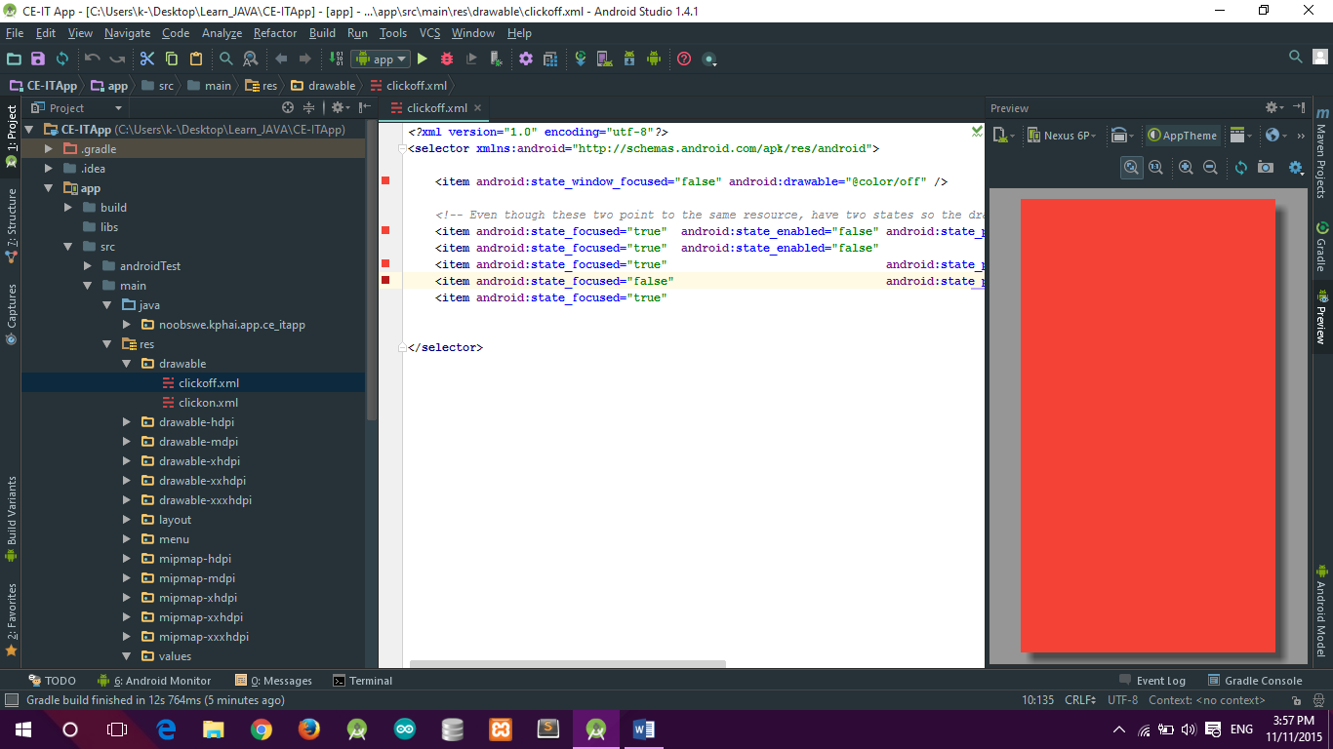

***clickoff.xml***

*<?***xml version="1.0" encoding="utf-8"***?>*<**selector xmlns:android="http://schemas.android.com/apk/res/android"**>  
  
 <**item android:state_window_focused="false" android:drawable="@color/off"** />  
  
 *<!-- Even though these two point to the same resource, have two states so the drawable will invalidate itself when coming out of pressed state. -->* <**item android:state_focused="true" android:state_enabled="false" android:state_pressed="true" android:drawable="@color/off"** />  
 <**item android:state_focused="true" android:state_enabled="false" android:drawable="@android:color/transparent"** />  
 <**item android:state_focused="true" android:state_pressed="true" android:drawable="@color/off"** />  
 <**item android:state_focused="false" android:state_pressed="true" android:drawable="@color/clickedoff"** />  
 <**item android:state_focused="true" android:drawable="@android:color/transparent"** />  
  
  
</**selector**>

***res 🡪 drawable 🡪 clickon.xml***

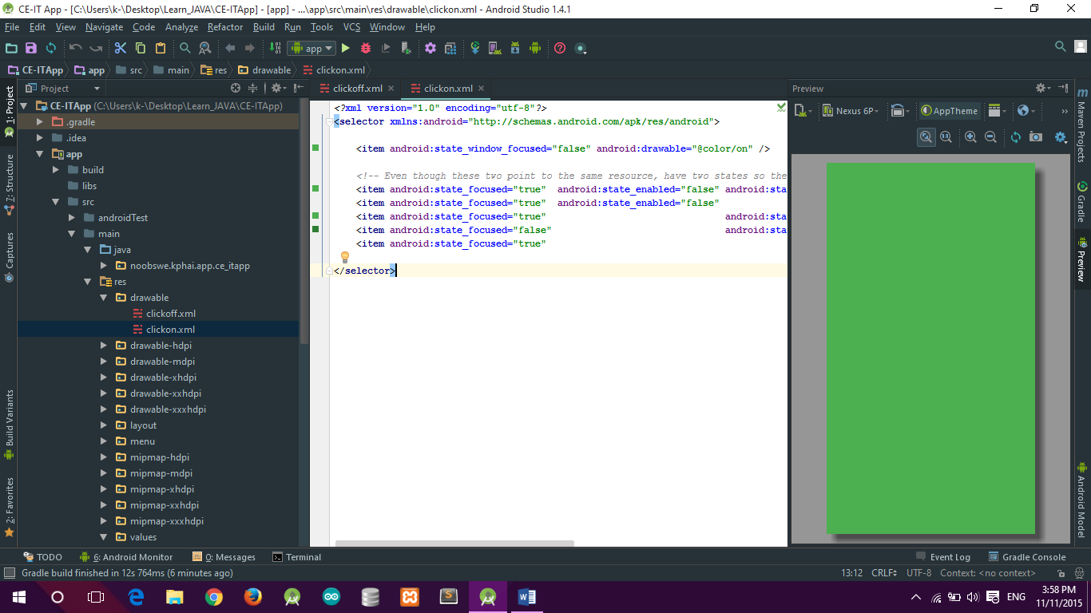

***clickon.xml***

*<?***xml version="1.0" encoding="utf-8"***?>*<**selector xmlns:android="http://schemas.android.com/apk/res/android"**>  
  
 <**item android:state_window_focused="false" android:drawable="@color/on"** />  
  
 *<!-- Even though these two point to the same resource, have two states so the drawable will invalidate itself when coming out of pressed state. -->* <**item android:state_focused="true" android:state_enabled="false" android:state_pressed="true" android:drawable="@color/on"** />  
 <**item android:state_focused="true" android:state_enabled="false" android:drawable="@android:color/transparent"** />  
 <**item android:state_focused="true" android:state_pressed="true" android:drawable="@color/on"** />  
 <**item android:state_focused="false" android:state_pressed="true" android:drawable="@color/clickedon"** />  
 <**item android:state_focused="true" android:drawable="@android:color/transparent"** />  
  
</**selector**>

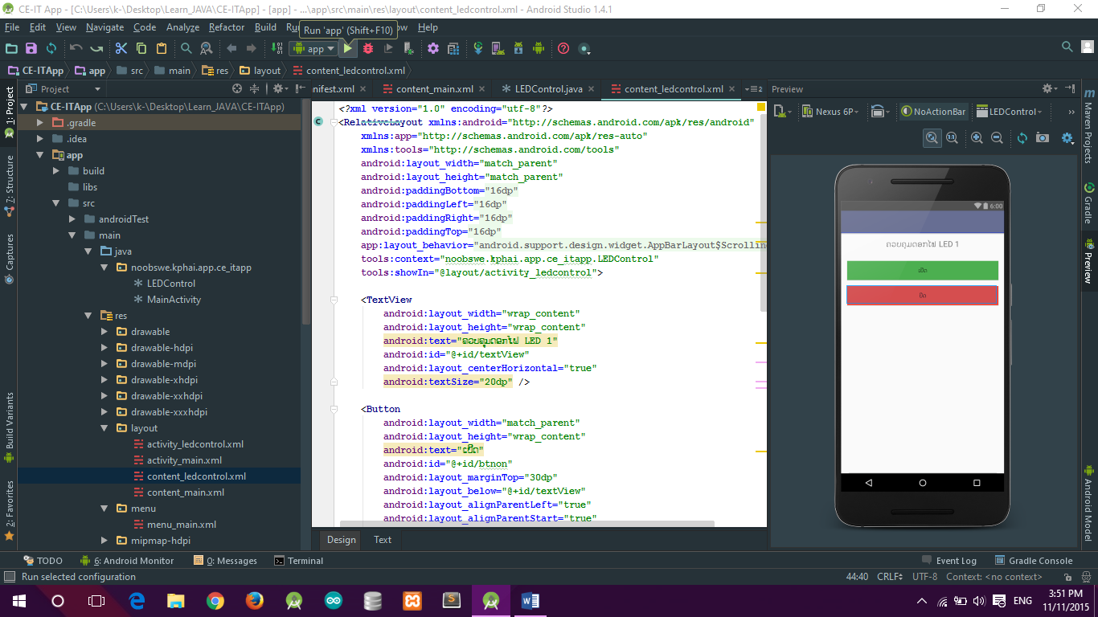

*Run*

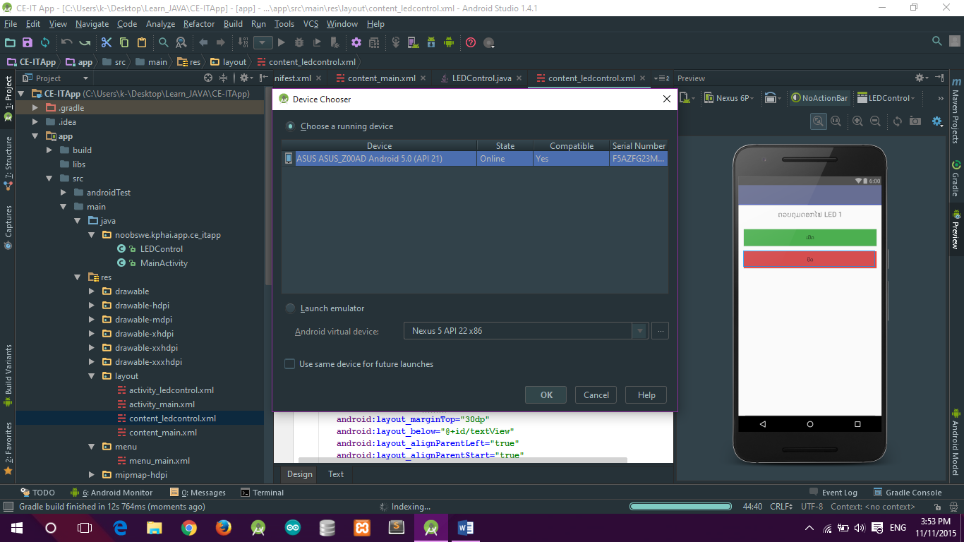

**Code Arduino**

*char command;*

*String string;*

*int led = 6;*

*void setup() {*

*// put your setup code here, to run once:*

*Serial.begin(9600);*

*pinMode(led, OUTPUT);*

*}//end of setup--------------------------------------------------------------------------------------*

*void loop() {*

*// put your main code here, to run repeatedly:*

*if (Serial.available() > 0){*

*string = "";*

*}*

*while(Serial.available() > 0){*

*command = ((byte)Serial.read());*

*if(command == ':'){*

*break;*

*}else{*

*string += command;*

*}*

*delay(1);*

*}// end of while--------------------------------------------------------------------------*

*if(string == "A"){*

*LEDOn();*

*}else if(string =="B"){*

*LEDOff();*

*}*

*}// end of loop---------------------------------------------------------------------------------------------*

*void LEDOn(){*

*digitalWrite(led, HIGH);*

*Serial.println(string);*

*}*

*void LEDOff(){*

*digitalWrite(led, LOW);*

*Serial.println(string);*

*}*

**Circuit**

